11/29/2023

Brenda Beach & Jonathan Hardwick

Video Game Library & Sales

Video Game Library & Sales

User Manual

Contents

**Installation of Required Programs to Write Code** 1

**Installation of Python** 1

**Installation of Visual Studio Code** 6

**Clone GitHub Repository CSC289** 14

# **Installation of Required Programs to Write Code**

Currently, the Video Game Library and Sales program is not set to be run by an executable, so you will need to download and install a couple of programs if you do not already have them. Those programs are Python and Visual Studio Code. You can use a different IDE other than Visual Studio Code, but for this installation manual, we will be using Visual Studio Code.

## **Installation of Python**

1. The first thing you need to do to install Python onto your system is to go to the website <https://www.python.org>.

1. Once you have arrived at the website, you will click on the Downloads link and then click on the link to download the latest version of Python onto your system.

1. Python will download to your default downloads folder, and once it has been completed, you can click on the icon to view your downloaded file names in the upper right corner of your webpage so you can click on that file name and install the program onto your system.

1. Click on run to install Python onto your system.

1. Click “Add Python to PATH,” then click Install Now.

1. The program will now be installed on your system, and the status bar will show the progress level of the installation.

1. Once the installation is finished, click on Close to close the setup window. You can then close the web browser.

1. To verify the installation of Python onto your system, you can click on the Windows icon, also known as your start button, and under the recently added programs, you should see the Python program.

1. You can also verify that Python installed on your system by opening a command prompt, and typing python –version. If you get an error message when you run this command, you must repeat these steps to reinstall Python on your system.

1. Now that Python is installed on your system, it is time to install our IDE so we can view our code and run the program.

## **Installation of Visual Studio Code**

1. To install Visual Studio Code, go to the webpage <https://code.visualstudio.com>.

1. Click on download to download to your default downloads folder, and once it has been completed, you can click on the icon to view your downloaded file names in the upper right corner of your webpage.

1. Click on the file name to install Visual Studio Code on your system.

1. Click on run to begin the installation of Visual Studio Code.

1. Click on I accept the agreement, then click on Next.

1. Click Browse to select the location to install the program or leave it as the default location. Click Next to continue.

1. Click Next to accept the default location and continue to the next step in the installation process.

1. Click Create Desktop Icon, then click Next to continue to the next step of the installation process.

1. Click Install to install Visual Studio Code onto your system.

1. Visual Studio Code will now be installed on your system, and the status bar will show you the progress of that installation.

1. Once the program has been installed, ensure that the “Launch Visual Studio Code” is checked before you click Finish. This will close out the installation window and start the Visual Studio Code. You can also go ahead and close the web browser.

1. Visual Studio Code will now open. You will need to click on the extensions icon so we can install the Python extension and write our Python code inside Visual Studio Code.

1. Click on Install under the Python Extension.

1. It will then install the Python extension. Once it is finished, you can write your Python code without receiving any errors.

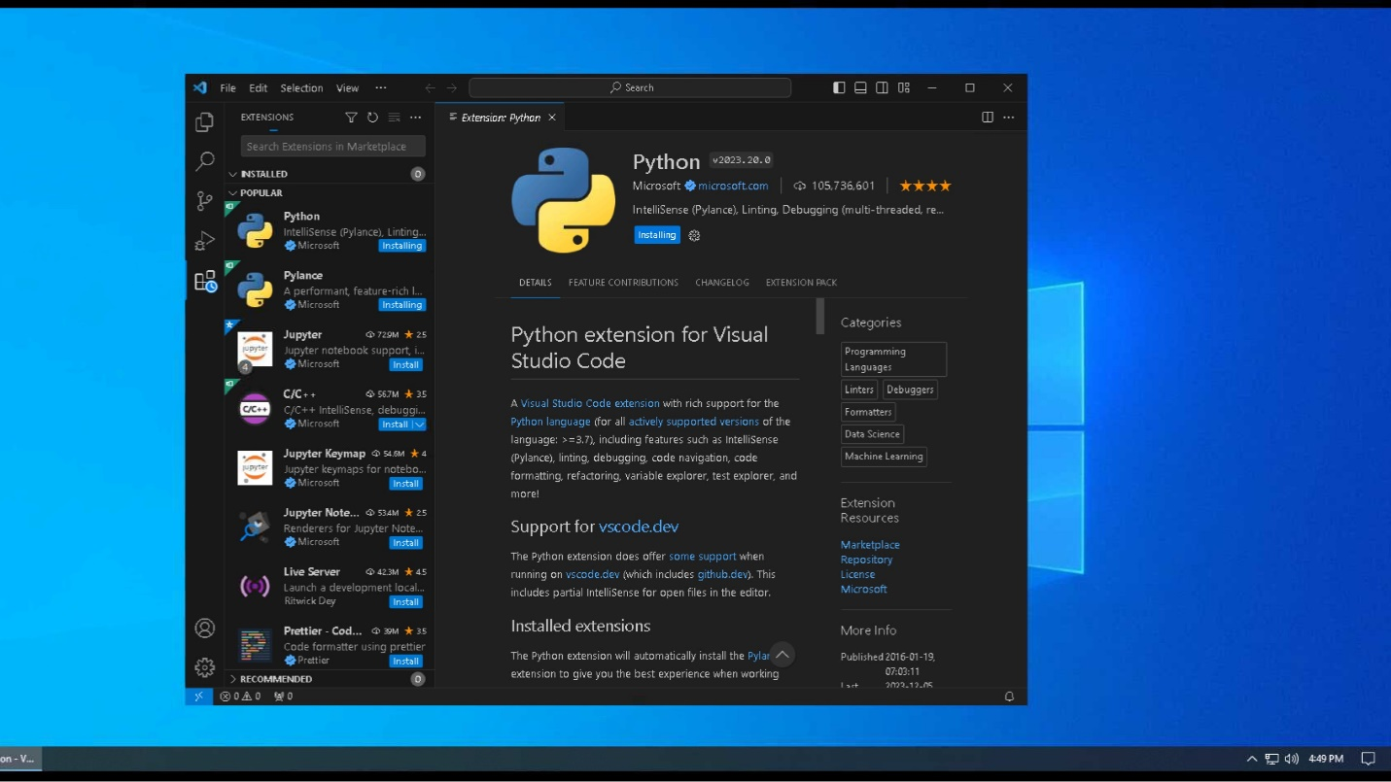

## **Clone GitHub Repository CSC289**

1. Go to the URL of <https://github.com/MrChiff/CSC289>.

1. To download the code in a zipped file, click on the green button that says “<>Code” and then click on the Local Tab.

1. Click on Download ZIP, then select the location where you want the file downloaded if it brings up that option. If it does not, then it will download to your default folder for downloads.

1. Open the folder to which you have saved the zipped file and right-click on it. Select Extract All so you can extract everything you have downloaded from GitHub.

1. Select the folder to which you want to extract all the files, then click on Extract.

1. The files will now be extracted to that folder.

1. Once the files have been extracted, double-click on the new folder to open it and view the contents.

1. Double-click on the following folder to open it and view the contents.

1. Now, you will verify that all files have been downloaded. Once you have verified it, you can open the project inside Visual Studio Code and create your virtual environment.

